Broker Agent Management

For property dealing PropTiger acts as the Contract Broker for the customers. There are agents to deal with the customers for the various property(-ies) they are interetsed in.

About :

The Broker Agent Management webpage facilititates the entry of new brokers into the database. This is done by taking as input a number of parameters of the individual broker itself and includes some specific personal as well as professional information as described below.

- The professional information includes the Company Name, Agent Name, Agent Role and Status (Active/Inactive) of the broker. A broker no longer/currently not associated into the management process is marked Inactive status to reflect the same.
- Regarding the personal information various details like Address, City, Pincode, Phone No, Mobile, E-mail, Educational Qualification and experience is stored (Operational Since).

The screenshot is attached for a clear view of this section of the webpage.

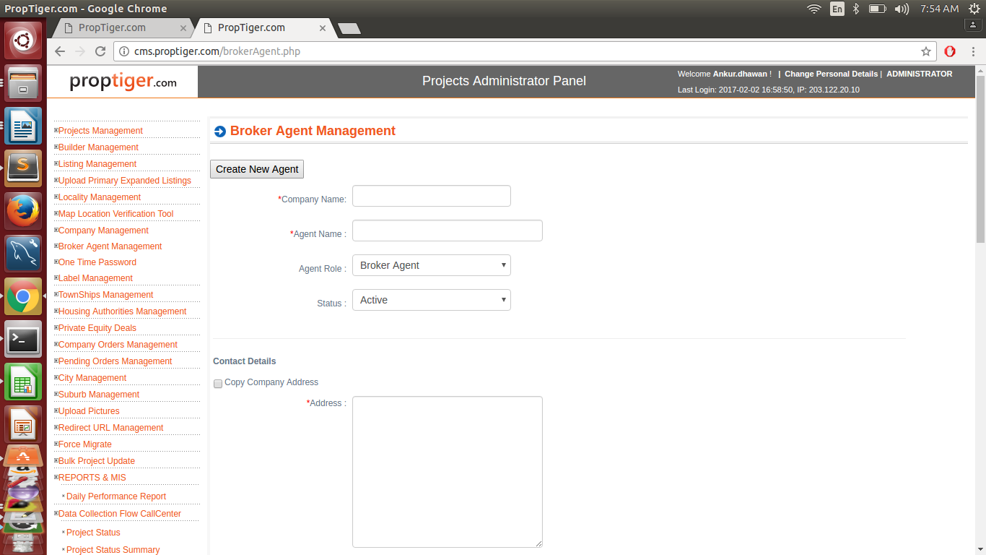

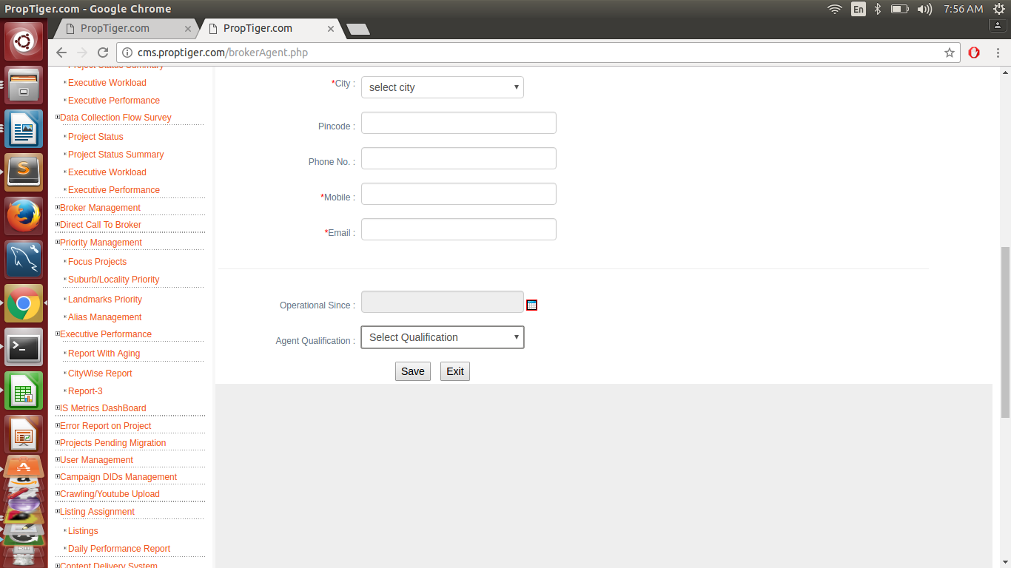

Following tables are use:
1.Company.
2.Academin_qualification.
3.broker_project_mapping.
4.company_users.
5.contact_numbers.

Mandatory Fields are:

- company name.
- agent name.
- agent role ( drop down).
- status.( drop down).
- address.
- city.
- mobile number.
- Email.
- agent qualification.

